Name : Saurabh Sanjay Jadhav

Topic : RDS service

Assignment no. : 23

1. Click Create database, choose a creation method-standard, engine type-MySql.

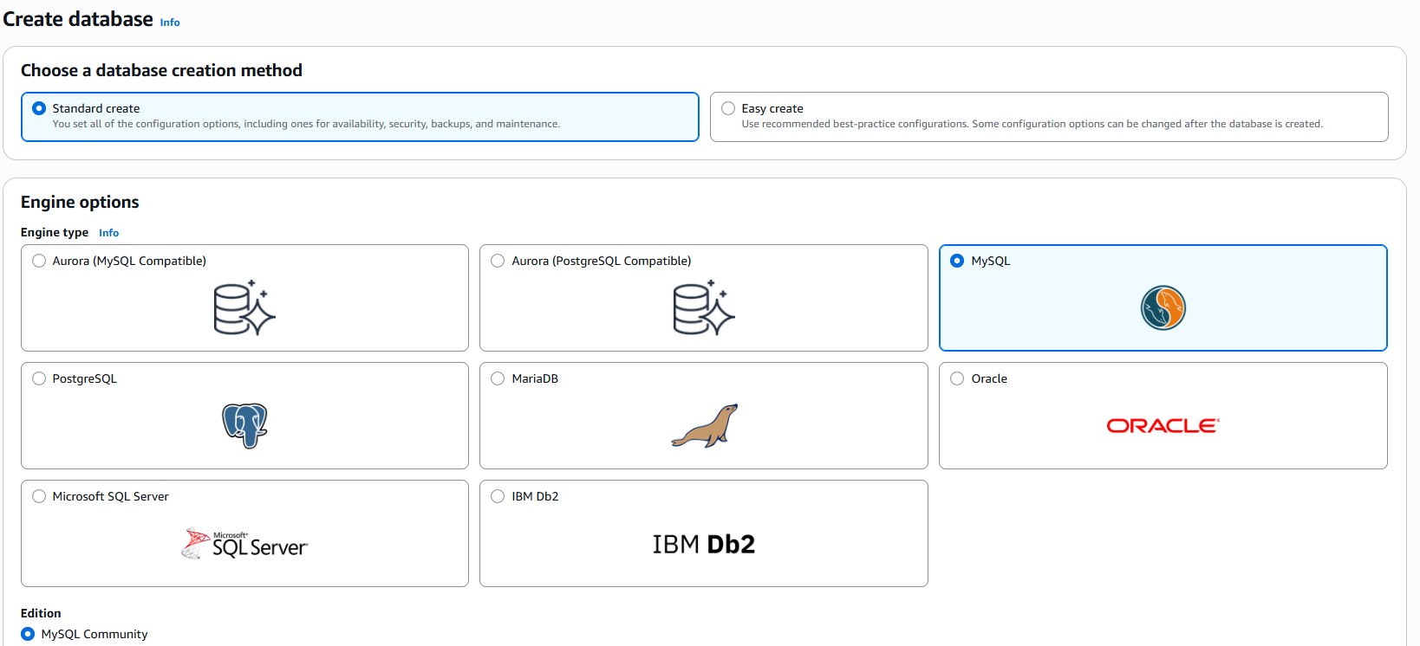

1. Select the version of database engine – 8.0.36.

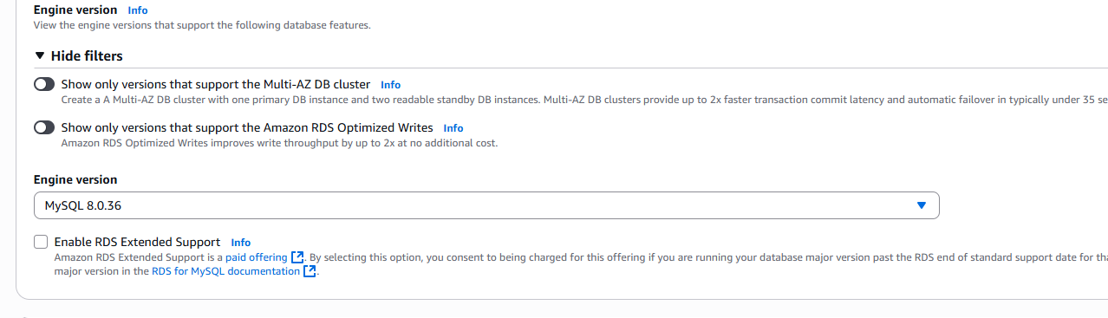

1. Select the template – dev/test and deployment option – single AZ

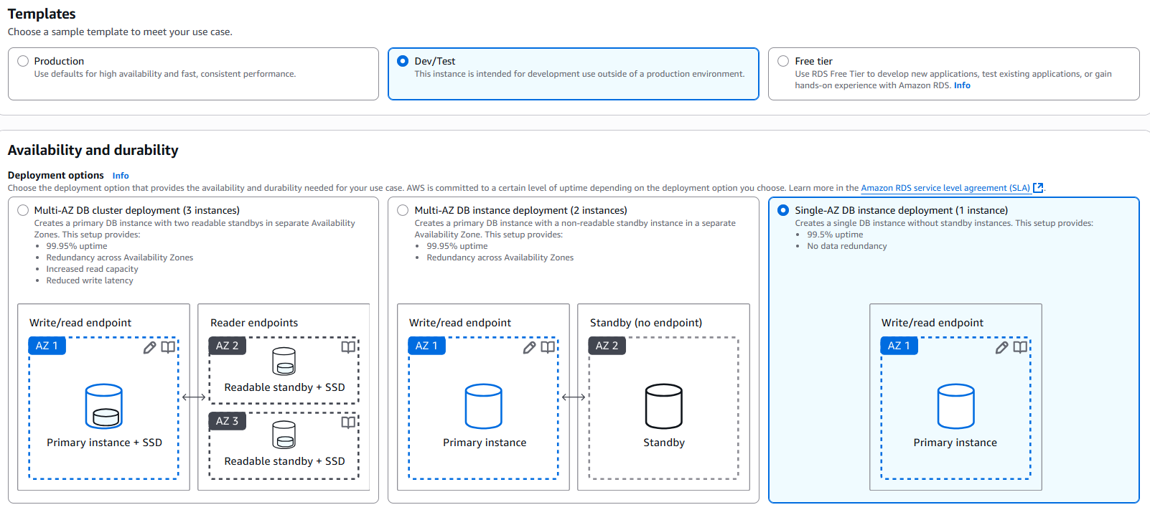

1. Provide database name : rds-1

Provide username and password for login.

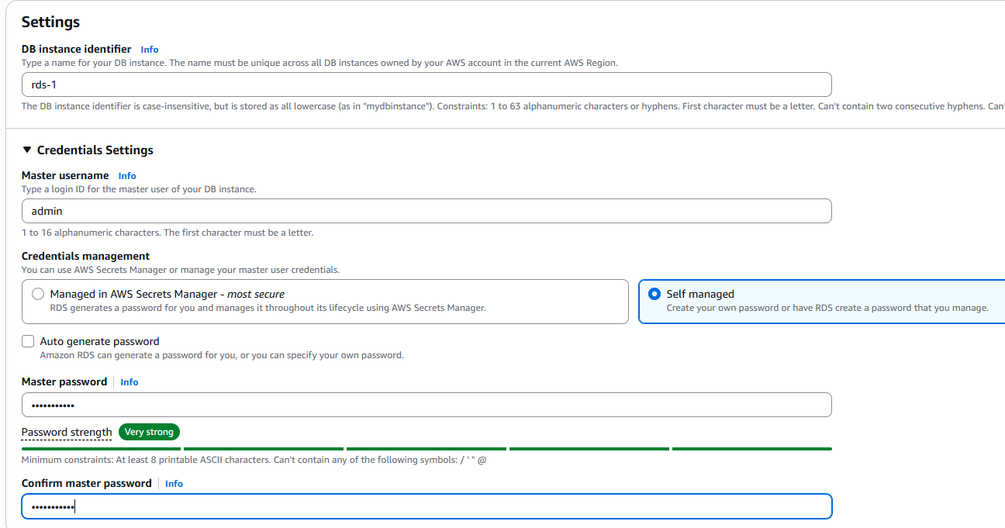

1. Provide instance class type – Burstable class.

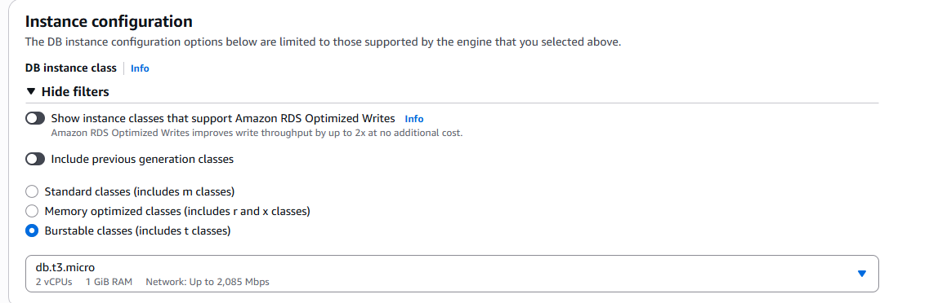

1. Storage configuration.

Storage type : gp3, Allocated storage:20

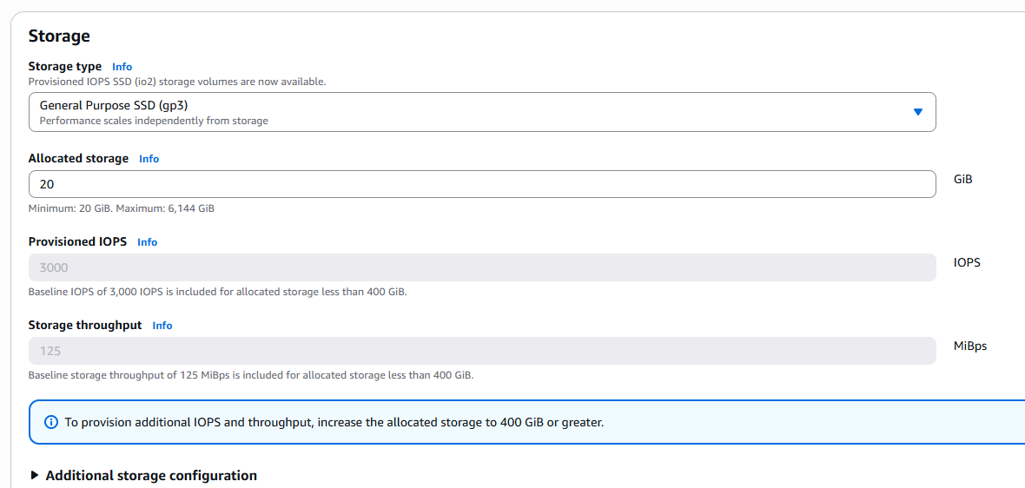

1. Connectivity configuration.

Keep options as default but change public access to yes.

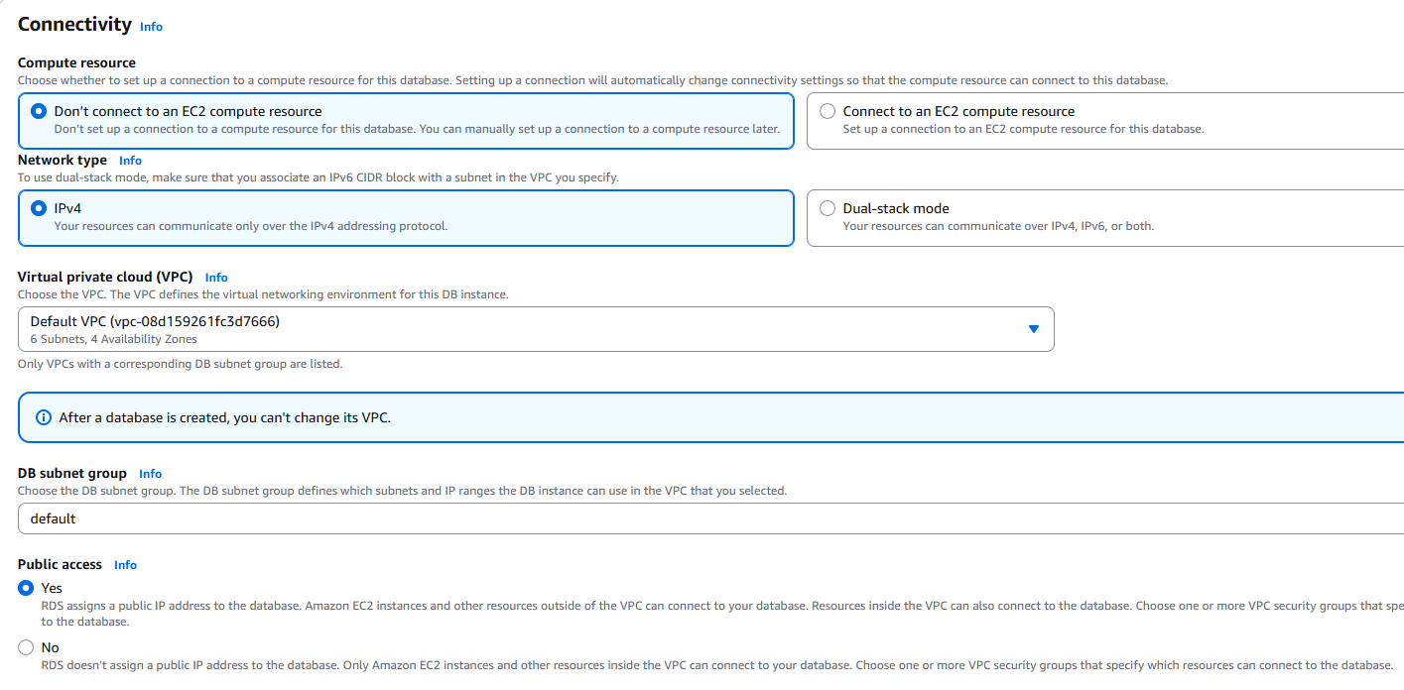

Security group configuration.

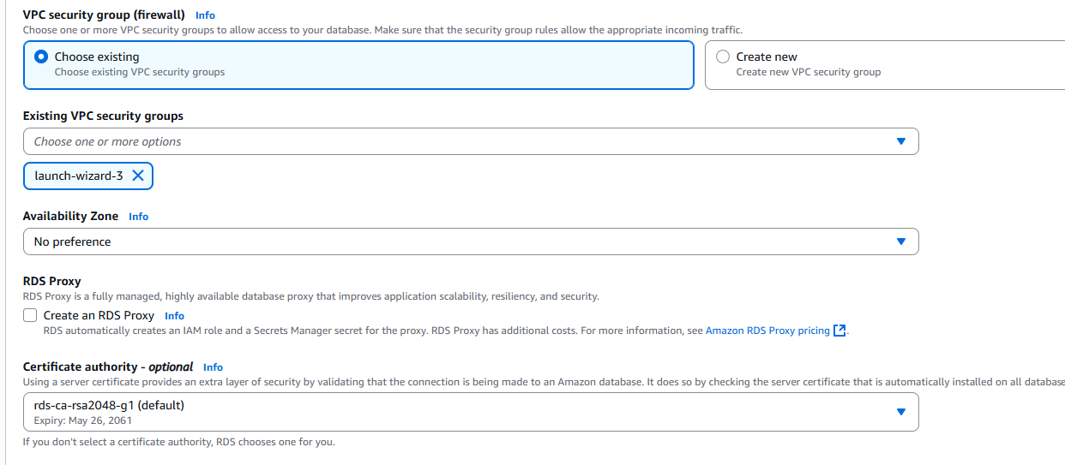

1. Authentication options.

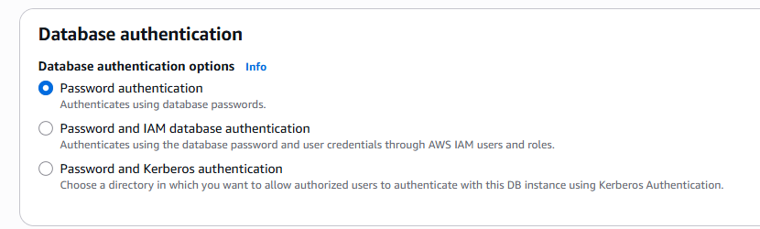

1. Check monthly costs of our database.

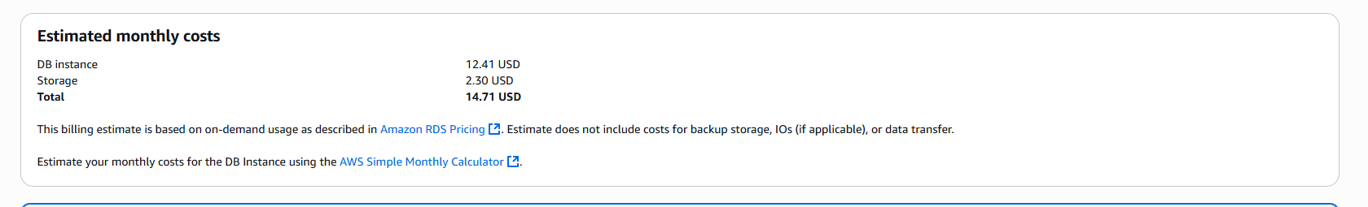

1. Create instance.
2. Name : instance-1

Select OS : Ubuntu

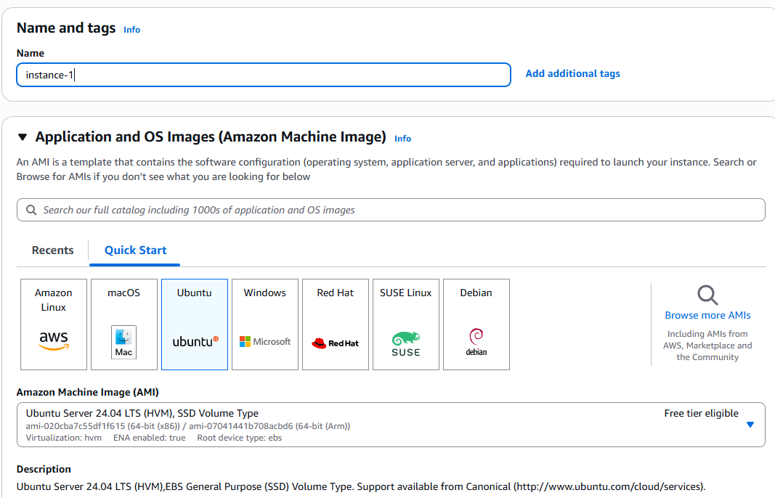

1. Instance type : t2.micro

Key pair: select existing.

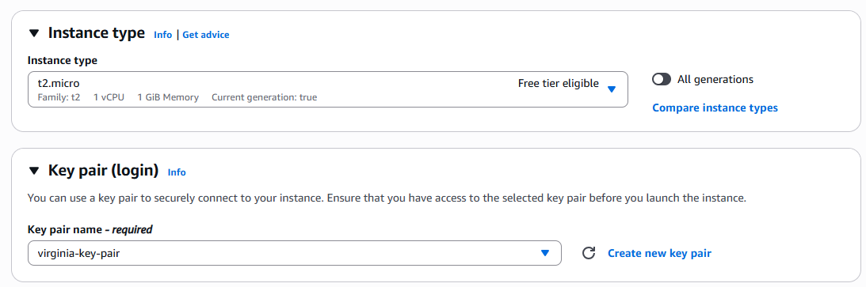

1. Network configurations.

1. Connect to instance

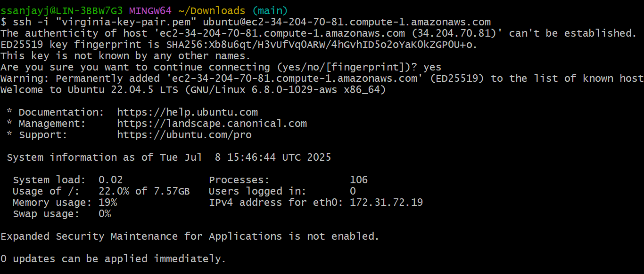

1. Install mysql

Apt install mysql-client

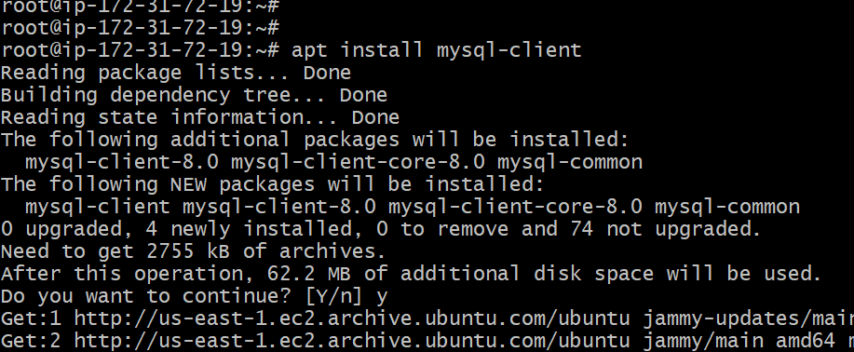

1. Connect to endpoint “rds-1.cqdom66ygajc.us-east-1.rds.amazonaws.com” of rds service.

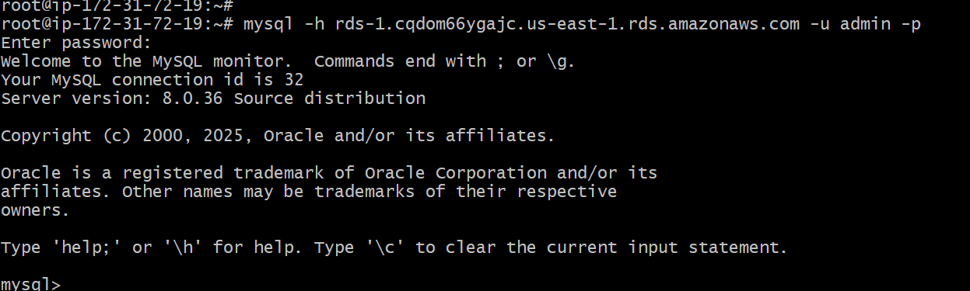

1. After successful connection try some mysql commands.

